10

MbUnit

Check your source code for bugs
No software is with out bugs so it’s vital you find them and squash them before your customers get hit by them. Unit testing needs little introduction but lets you test your code as you write it or after to make sure it behaves as you expect. Unit testing frameworks facilitate that testing while keeping to your language of choice. MbUnit was developed as a freeware framework by Jonathan De Halleux and Jamie Cansdale and is now an opensource framework under the guidance of Andrew Stopford.
Tool | MbUnit
Version | 2.3
Homepage | http://www.mbunit.org
Power Tools Page
Summary | Fully featured open source unit test framework with many powerful and unique features.
License Type | Opensource
Resources | Wiki , blogs, mailing list community
Supported Frameworks | 1.0, 1.1, 2.0
Related Tools | NUnit, Zanebug, Testdriven.net, NCover, NCoverExplorer
MbUnit fully supports the same features as NUnit and CsUnit (and switching from these can be done with a simple change to the references) and additional adds a wide range of asserts and fixtures.

Requirements
Normally included in Tool Overview unless something odd such as weird licensing or weird tech requirements mandate a separate Requirements section
What the tool needs (hardware, libraries, etc.). If the tool runs in VS, note which version. Note which version(s) of the framework it supports.

Setting Up and Running
Details on how to get the tool/system up and going. Note any particular pitfalls.
If Possible:
If the tool is standalone, show how to wrap into NAnt or MSBuild as part of a CI system.

Notes on Figures
See O’Reilly’s guidance on illustrations here:
http://ora-design.ora.com/illus_dept/!author.html
Basically that breaks down to: check for Moire patterns on your scrollbars (directions on that link), use the best monitor you have, and don’t convert or otherwise fool with the format.
NOTE: do not resize graphics in the Word files. Just insert them full-sized and the smart folks at O’Reilly will handle getting them properly sized on the page.
Please use the following format for figure filenames: “wdpt-ch4-xsd1-opening.png” where “wdpt” is the prefix for our book’s title (Windows Developer Power Tools), “ch4” is the chapter number for the article you’re working on, and “xsdl-opening.png” is the name of the tool you’re writing on plus a sensible label for what’s being shown.
Please fill out the List Of Figures file as shown in the example in that file.
Insert figures using the “Figure with Caption” button on the O’Reilly Toolbar. That will give you a browse box and automatically insert a caption. Use Cross-References in the text to reference figures. Alt-X will pull up the Cross-Reference dialog.
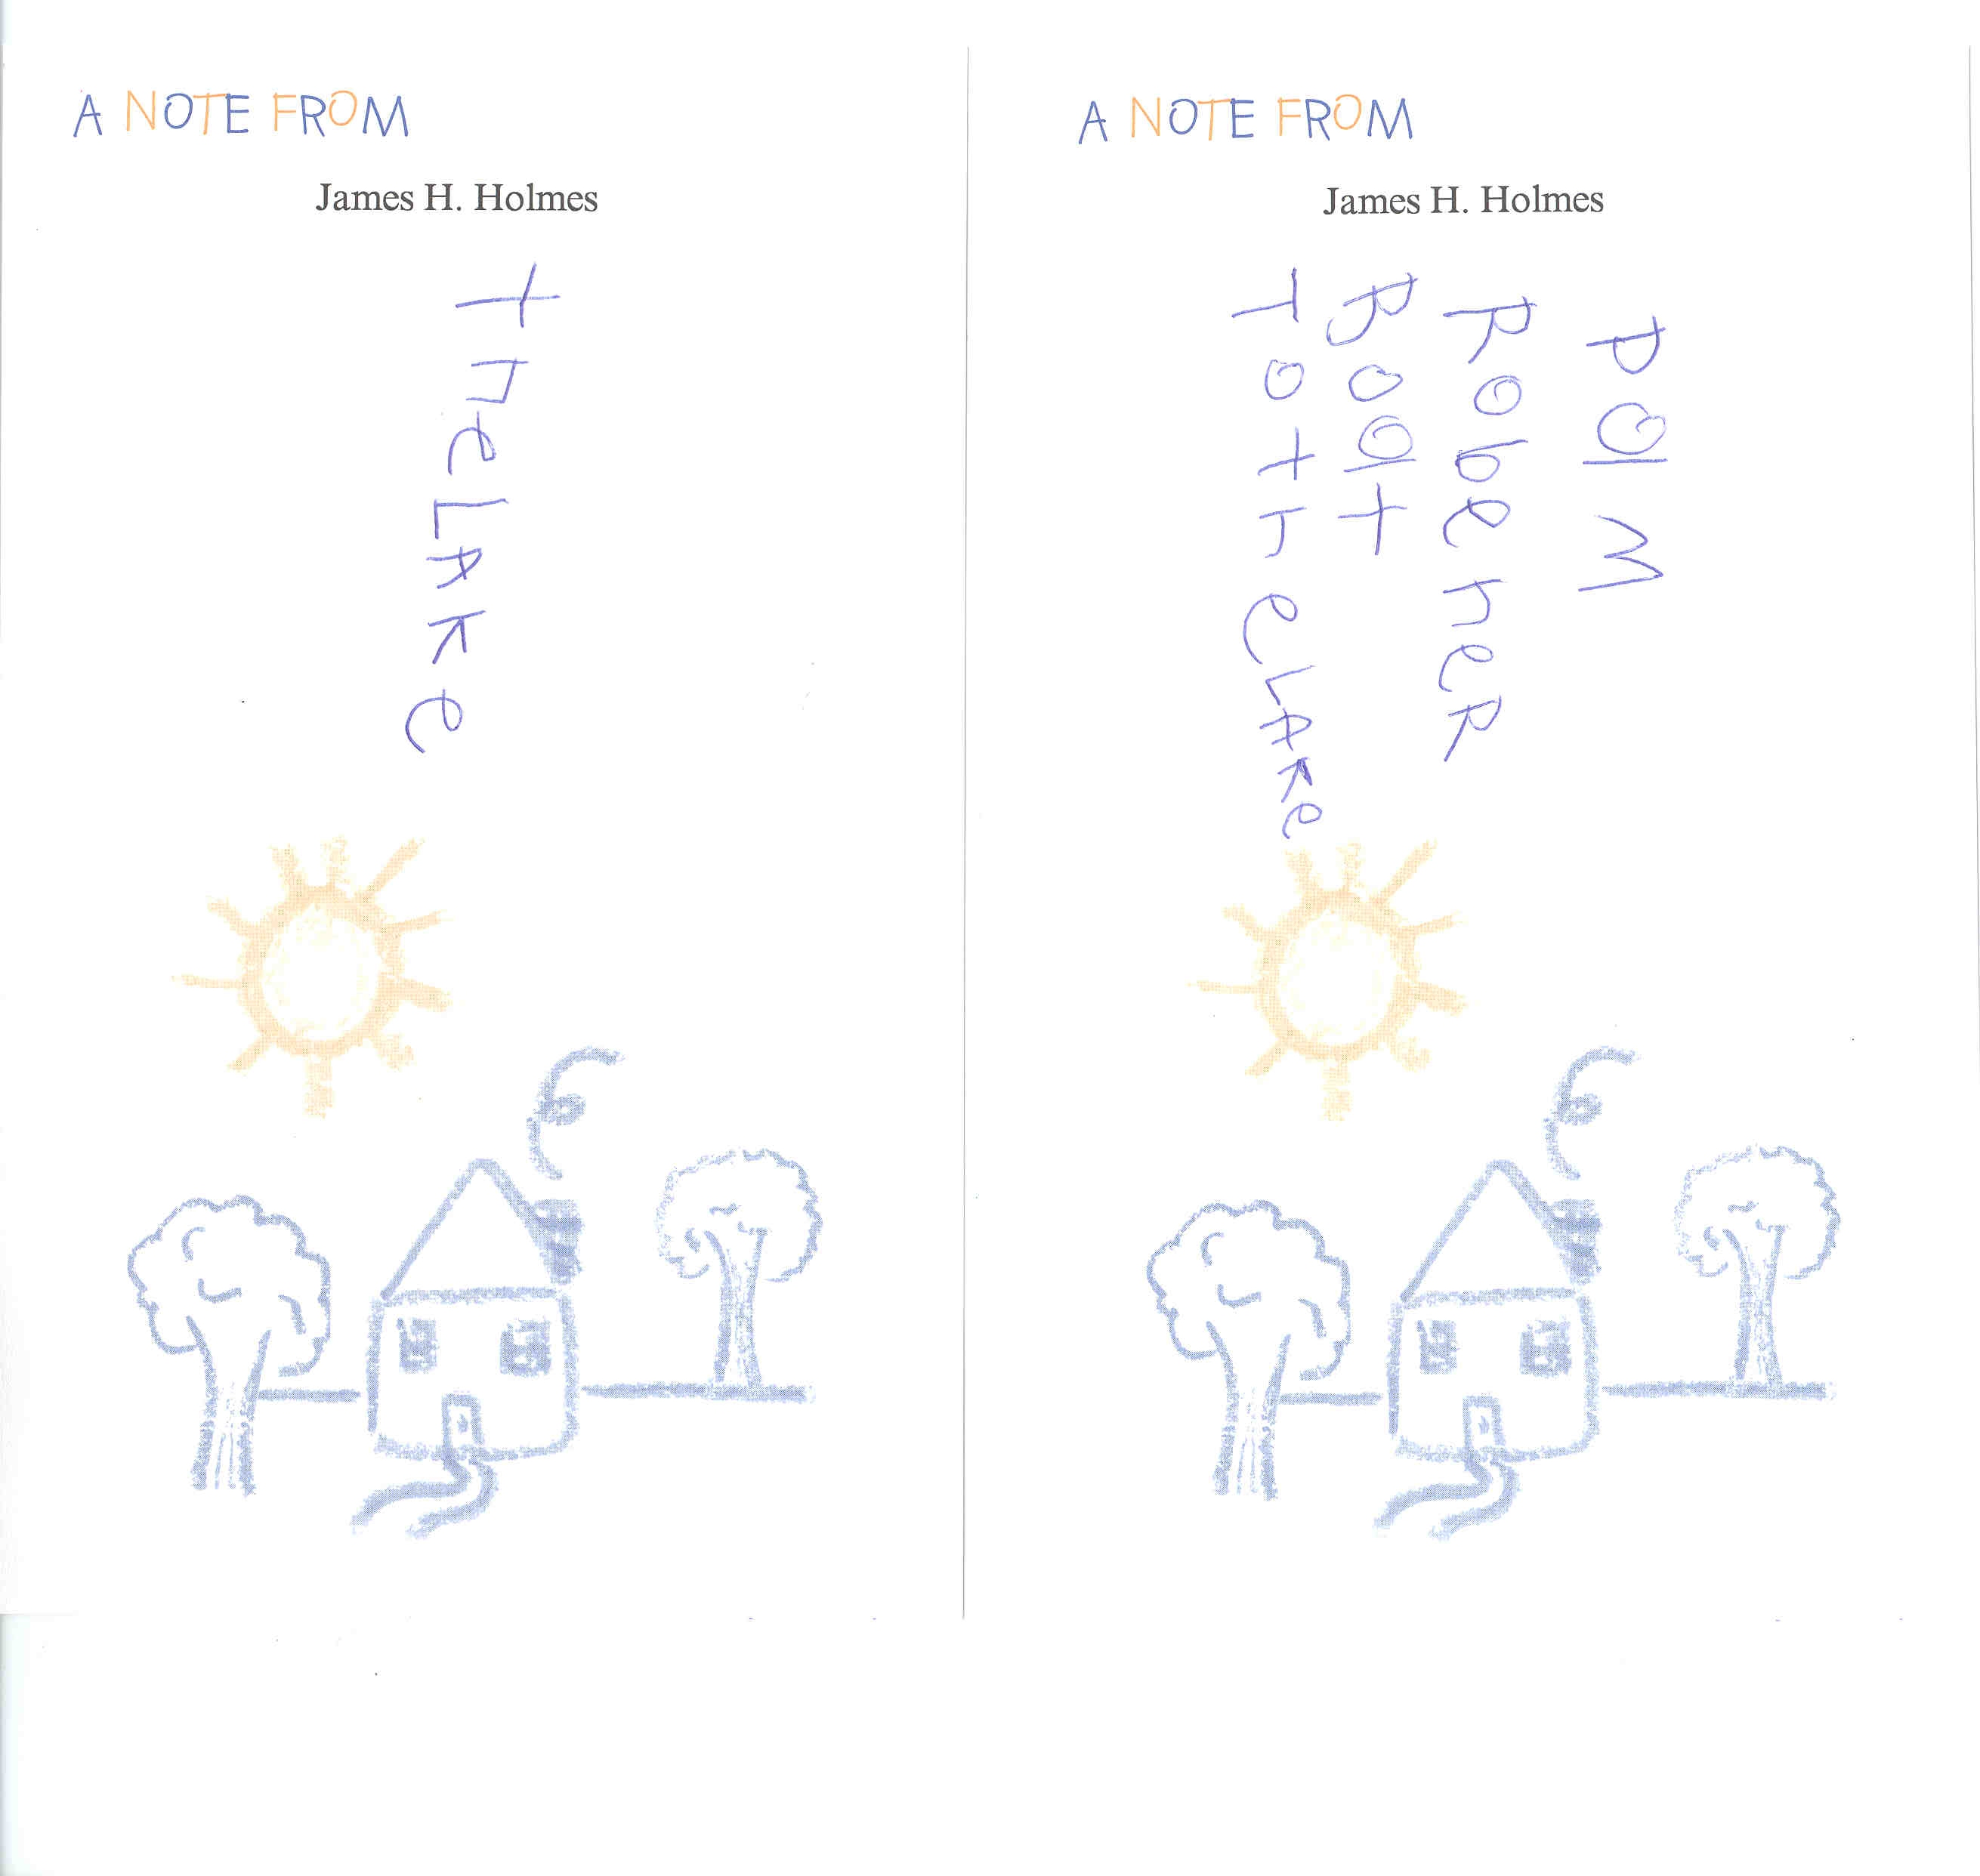
Figure 1-1. Figures get inserted using the “Figure With Caption” on the Oreilly Tools widget

NOTES FOR INDEX
Please help the book have a killer index. Collect all terms you think should be added into an index and consolidate them in a separate text file. Include terms for tools, major framework classes you might use, concepts (“cyclomatic complexity” or “mathematical differentiation”), or any terms you would like to see in a good index.

NOTES ON LISTS
- Use the O’Reilly toolbar for lists
- This one is a bullet list.
- Duh.

NOTES ON CODE EXAMPLES
Code can’t be more than 85 characters per line. Paste in your example code, style it as “Code”, then select ORATools →Inspect→Check Code Line Lengths.
Also fix up any tabs in your code. Use ORATools →Repair→Replace Tabs With Spaces.

NOTES ON FORMATTING
Do NOT format items with italics or bold via Word’s formatting options! Instead, use the formatting options under the O’Reilly toolbar’s Character Styles menu. There are keyboard shortcuts listed for these to satisfy keyboard junkies like myself.
Inline references to methods, classes, or any type of code-related stuff (GC.WaitForPendingFinalizers(), for example) must be formatted as “Literal” using Alt-L,C.
Filenames, directories, applications all get formatted as Technical Italic. For example: ExcelXmlWriter.Generator.exe is a filename. Technical Italic is also the right choice for term names you’re trying to call attention to, such as “This dialog allows you to enter the CVSROOT string.”
Menu items do not get styling other than Body Text. Type the entry as is for one or two word items. Longer items get enclosed in quotes ONLY if they’re mixed case. Short example: The File menu. Long example: The “URL to download recursively” field option.

Usage
Ok, so the user can setup and run the tool… how do they actually use it in their everyday life? Make workflow recommendations, tips, tricks, things that make this a compelling tool.
This doesn’t need to be specifically titled “Usage.” Something like “Using the Metrics” or “Creating a Project” is fine, especially if there are several distinct steps for a tool.

See Also
Reference to other similar topics in the book.

Support
Lay out where the tool is supported. Note whether the tool is stabile, beta, alpha, etc. Also note whether development on the tool is stale or active. Wrap this part into the summary.

Summary
This should be your general statement on the tool, kind of like a elevator speech. Cover any Pros and Cons that were not already mentioned in the article as well as any thoughts on the future development of the tool.

Other notes:
- Figures: see O’Reilly’s guidance for making screenshots at http://ora-design.ora.com/illus_dept/!author.html. Basically save everything in unaltered, untweaked PNG format.
- Figure naming: use this convention for filenames: “wdpt-ch8-crmetrics-first-window.png”. That’s “wdpt” for Windows Developer Power Tools, the chapter, the tool name, and something descriptive of the shot.
- Index terms: keep a list of terms from your article you’d like to see in the index. At a minimum, list all tools, framework classes, critical concepts. Think of stuff YOU would look for in the index.

